* INTRODUCTION

Global warming is one of the biggest challenges currently being faced by the human race, although correlation is not causation, a likely cause of global warming is due to increased atmospheric carbon dioxide from human activities. CO2 Emission refers to the Carbon Dioxide emitted throughout the world. For this analysis we will be focusing on CO2 Emissions and its effect on the world we live in as well as some key factors and stats that may play a role in the emission of CO2 globally. Fossil fuel use is the primary source of CO2. The data throws light onto how much fossil fuels are burnt, per year per nation, which amounts to an increase in CO2 every year. This will help researchers and environment experts to predict global warming. So countries should set a goal to decrease this amount yearly. Analysing Global Co2 Emission across countries from 1975 to 2020. This dataset contains a record of Co2 Emission by each Country and Region of Earth, here we are going to analyse and visualise Country wise, Region wise and Overall Co2 Emission on Earth.

* PROBLEM DEFINITION & DESIGN THINKING

2.1 EMPATHY MAP

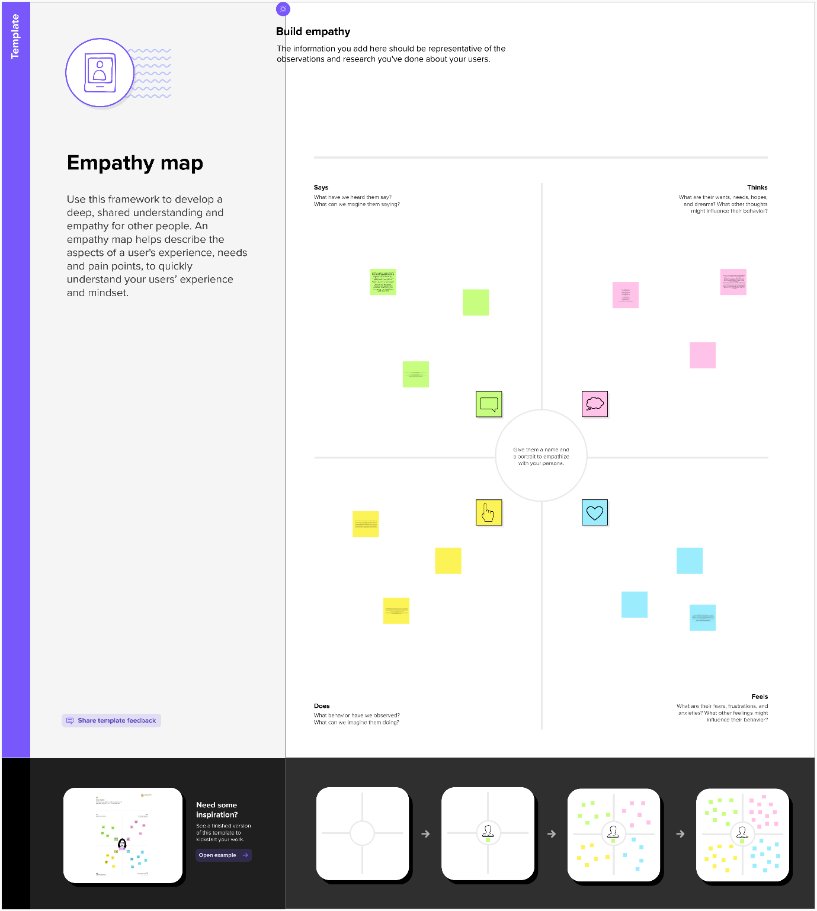

2.2 IDEATION &BRAINSTORMING MAP

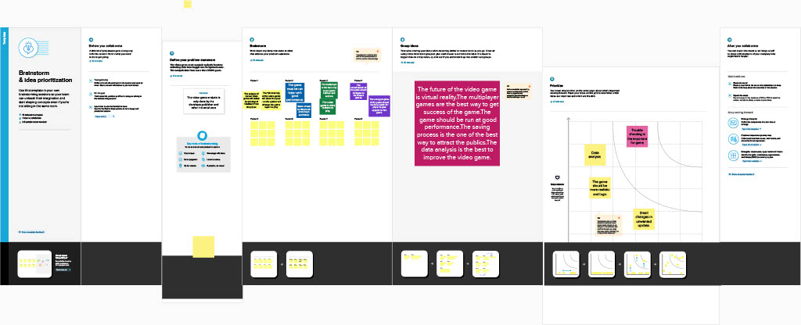

* RESULT

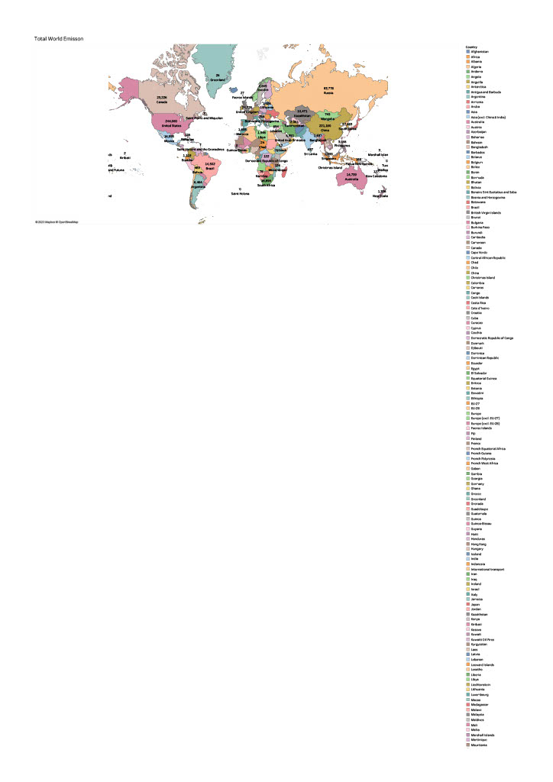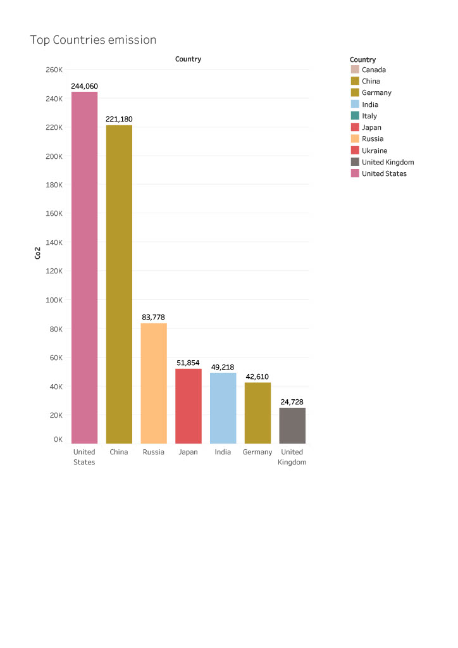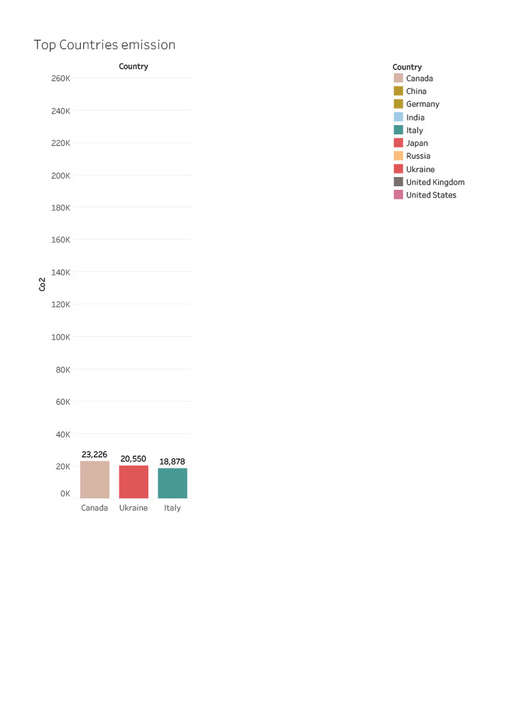

* ADVANTAGES

1. If you choose to walk, bike, or take public transportation instead of driving, you can save money on gas and car maintenance. You may even be able to

sell your car if you switch to a more sustainable mode of transportation.

1. By making your building more energy-efficient, you can save money on your energy bills. This is because you’ll be using less energy to heat and cool your offices, and you may even be eligible for certain energy-efficiency tax credits.

* DISADVANTAGES

1. According to [**National Geographic**](https://www.nationalgeographic.com/environment/global-warming/pollution/), carbon dioxide is considered a pollutant, though we may more readily associate “pollution” with things like smoke or plastic floating in a lake. But pollutants are anything that falls under the umbrella of a mix of particles and gases that have the capacity to reach harmful concentrations, according to National Geographic. Things like soot, smoke, mold, and pollen are considered pollutants, but greenhouse gases like methane and carbon dioxide are, too.
2. This warming causes extreme weather events like tropical storms, wildfires, severe droughts and heat waves. And while an increase in carbon in the air can, in some ways, positively affect plants and crops, if the climate changes the lands and causes drought or other weather events that crops and plants are unable to survive in, it can be detrimental to crop yields. The same problem holds for animals, as well; as climate change alters our environment and natural habitats, different indigenous species take a hit. Some species may disappear altogether, while others might thrive and overtake others.

* APPLICATIONS

Social Impact: Carbon dioxide emissions are the primary driver of global climate change. It’s widely recognised that to avoid the worst impacts of climate change, the world needs to urgently reduce emissions. Business Model/Impact: By conducting an analysis the countries can identify areas for improvement and take steps to reduce factors that are responsible for Co2 Emission for environmental sustainability by improving the efficiency and transitioning to low carbon alternatives.

* CONCLUSION

Data collection is the process of gathering and measuring information on variables of interest, in an established systematic fashion that enables one to answer stated research questions, test hypotheses, and evaluate outcomes and generate insights from the data.

* FUTURE SCOPE

There are lots of considerations beyond emissions alone – such as cost and practicality – but, to an extent, we can choose whether our fleet is low or zero emissions, we can determine how our buildings are warmed and a manufacturer can look at ways to reduce the carbon cost of its production processes.

However, a soft drinks maker can’t control how we will dispose of its plastic bottles, nor can an appliance manufacturer decree whether we use the most or least eco-friendly settings on our laundry machines.

* APPENDIX

1. SOURCE CODE

* STORY : <https://public.tableau.com/views/sindhuproject1/Story1?:language=en-GB&publish=yes&:display_count=n&:origin=viz_share_link>
* DASHBOARD:<https://public.tableau.com/views/sindhuproject1/Dashboard1?:language=en-GB&publish=yes&:display_count=n&:origin=viz_share_link>